“Hachaluz league”

A one stop shop mobile web application for managing youth soccer leagues

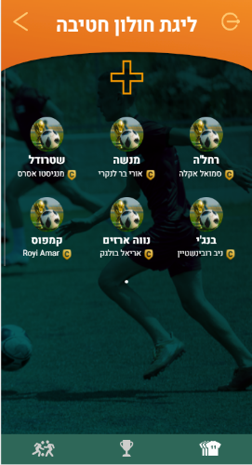

Personas:

The personas can be summed into 2 segments:

1. Managing personas – league organizers who create, add teams, manage players, and update the scoreboard.
2. Player personas -Participants in the league, who invite friends, join teams, and keeping check on their position and score on the scoreboard.

Acute Pains:

these could no longer be ignored and finally led to allocating resources for the development of the product

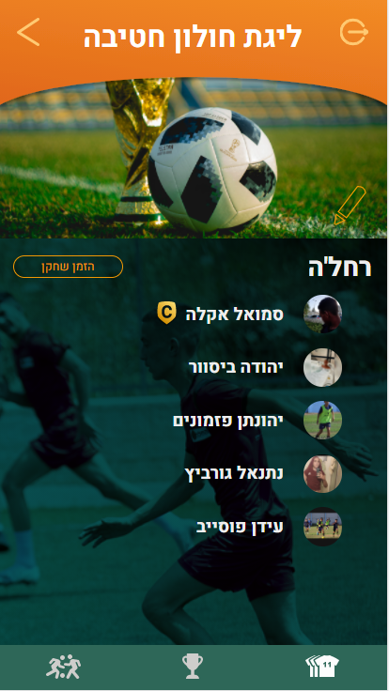

1. Managing personas receiving endless repeating questions, massages and what not about teams score after a game sessions. Consuming hours of work that could have used to further the organization goals.
2. Conventional league signup methods often led to incomplete or inconsistent data collection on participating players.

For example, errors in manually filled forms or miscommunication during registration frequently resulted in missing or inaccurate player details, such as contact information or preferences. The staff had to spend several hours manually reaching out to both new and returning players, often asking repetitive questions that frustrated participants. This not only increased labor costs but also risked alienating players, as the repetitive follow-ups created a negative user experience.

User experience wanted

1. The feeling of a major league event!

(תמונה של אצטדיון)

Solutions:

1. Scoreboard feature – streamline the score directly to the players.

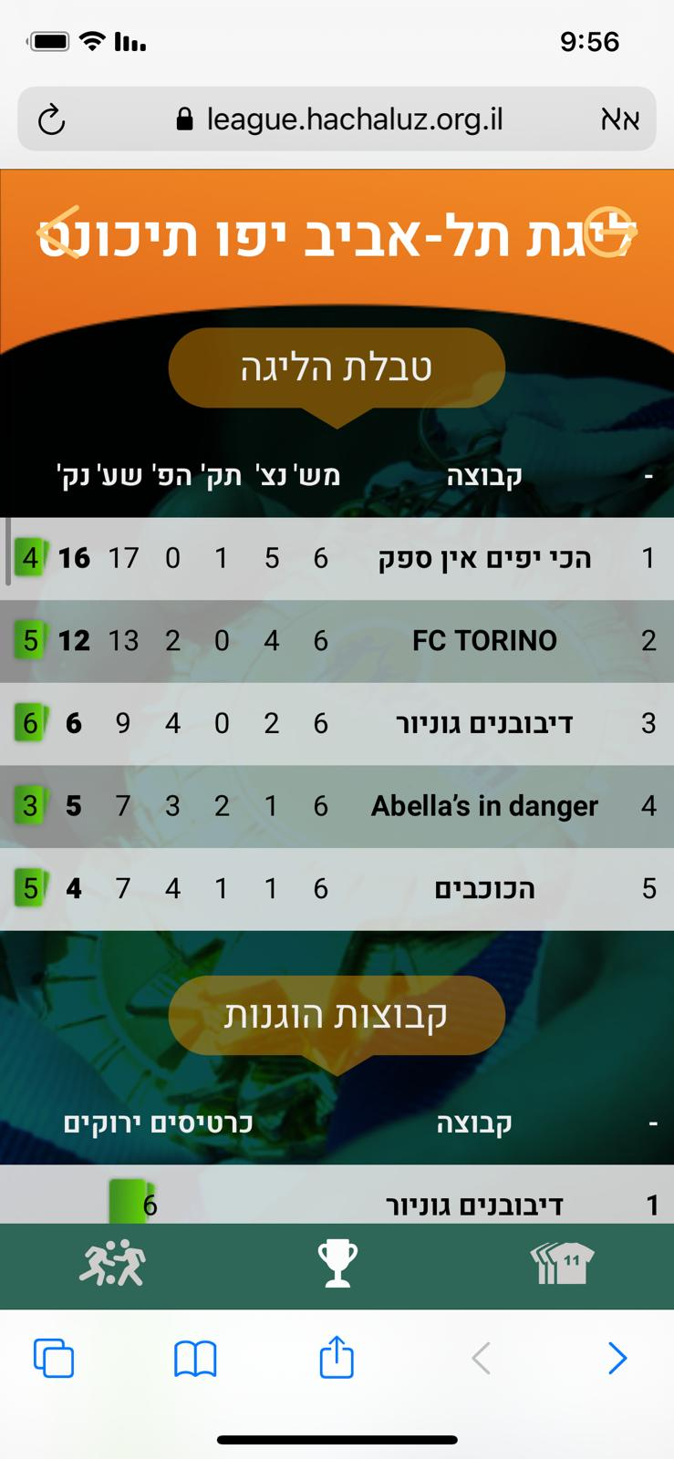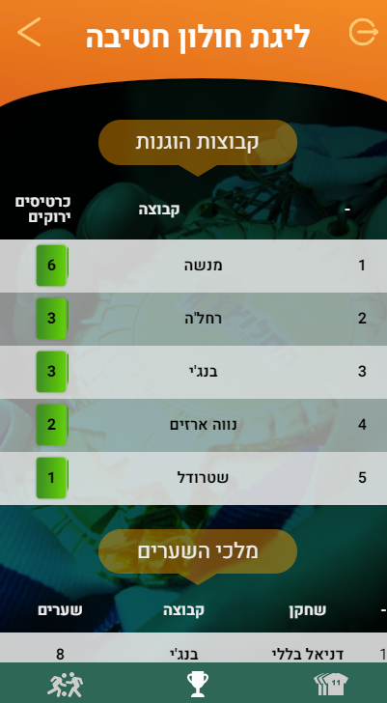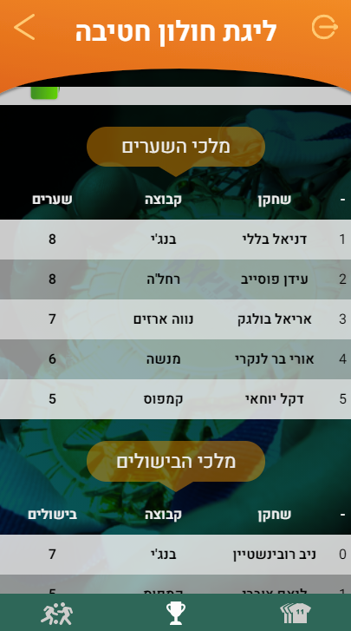

1. Signup system - users sign up into leagues and automatically get sorted into teams. Managers get streamlined league participants instantly, including key logistics information such as shirt size!

Use case examples:

1. As a player who wants to click on the scoreboard so that he can know the score of the last game.
2. As a referee who wants to fill a game report form, so that he can update the scoreboard with the games results.

KPIs met:

(Add graph)

1. Increased sales of league projects by 100%
2. Streamlined logistics involving league management
3. Increased player retention rate for future projects by an avg. of 250%

In collaboration with “Drorsoft”(link) and “Hachaluz – education through sports”(link)

**“leolam adam”**

Youth organizations content management system

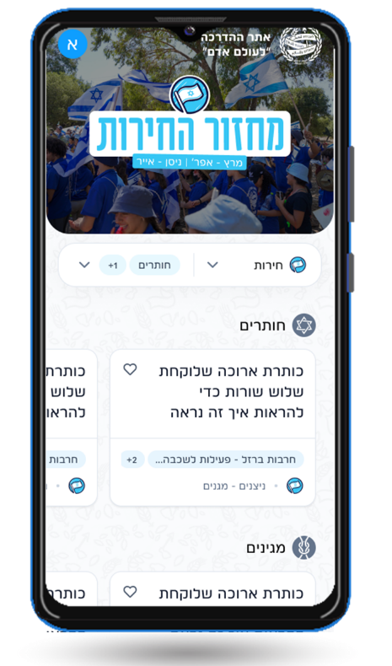

“Hanoar haoved vehalomed” is a youth organization who’s with many sprawling branches and different segments. One of the core challenges the organization faces as its growing in activity is how to systematically target and deliver content to the organization’s counselors. The content delivered should consider the segment of the counselor, actual events that happen around the work that relate to said content, and many more variables the effect what may be perceived as “value content”. Failure to do that will see a decline in participants which in turn will become a decline in income from donations and regulations.

**Platform:** Mobile and desktop

**Personas**:

1. Youth counselors – the content consumers of the site. Males and females from ages between 16 – 35 who volunteer in the organization.
2. Content creators – the content creators of the site. Males and females from ages 25-50 who work in the organization.

**Acute pains:**

1. Content creators lack the ability to create a centralized way to deliver content to youth counselors, to the point of losing previously created content, which in turn costs additional employee working hours.
2. Youth counselors rely on competition content rather than the organization’s, causes loss of trust in the organization, which later causes a decline of volunteering youth counselors – the corner stone of the organization.

**User experience wanted:**

**Solutions:**

1. Creating a platform for content creators to upload their content, and sort it automatically to the organizations’ many segments.
2. Creating an easily accessible platform for youth counselors to

**Use cases examples:**

**Kpis met:**

1. More then 80% of youth counselor volunteers are consuming content using the platform
2. Eliminated work to salvage previously created content
3. 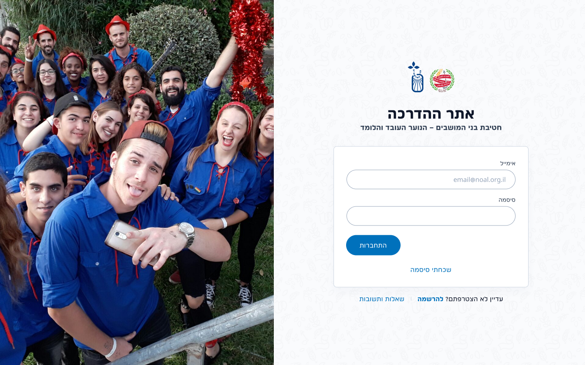Over 600 new activities are uploaded to the site each year as content by the organization!